**STRING MANIPULATIONS**

Instructions:

Please share your answers filled inline in the word document. Submit Python code and R code files wherever applicable.

Please ensure you update all the details:

**Name: Navya.P**

**Batch Id: WDEO 171220**

**Topic: Preliminaries for Data Analysis**

**Problem Statement:**

It is obvious that as part of data analysis we encounter a lot of text data which is a collection of strings which in turn is a sequence of characters. Access the text data and manipulate as per our requirements. you can go through this link for further assistance:

<https://360digitmg.com/mindmap-data-science>

1. Create a string “Grow Gratitude”.

Code for the following tasks:

1. How do you access the letter “G” of “Growth”?
2. How do you find the length of the string?
3. Count how many times “G” is in the string.

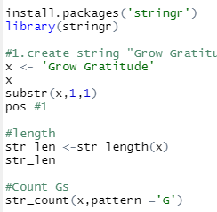 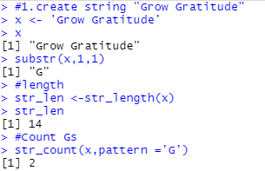

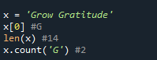

1. Create a string “Being aware of a single shortcoming within yourself is far more useful than being aware of a thousand in someone else.”

Code for the following

1. Count the number of characters in the string.

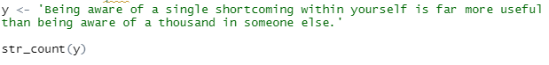

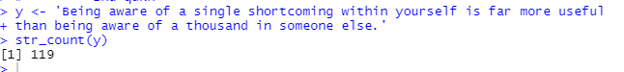



1. Create a string "Idealistic as it may sound, altruism should be the driving force in business, not just competition and a desire for wealth"

Code for the following tasks:

1. get one char of the word
2. get the first three char
3. get the last three char

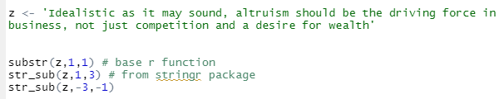

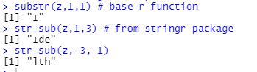

1. create a string "stay positive and optimistic". Now write a code to split on whitespace.

Write a code to find if:

1. The string starts with “H”
2. The string ends with “d”
3. The string ends with “c”

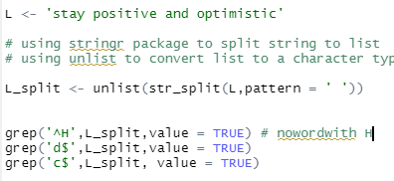 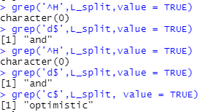



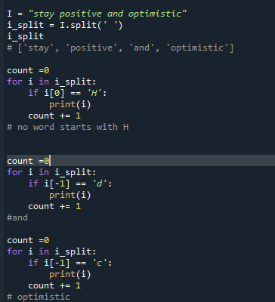 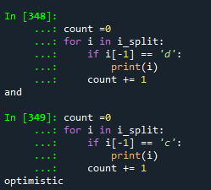

1. Write a code to print " 🪐 " one hundred and eight times. (only in python)



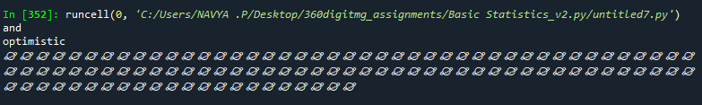

1. Write a code to print " o " one hundred and eight times. (only in R)





1. Create a string “Grow Gratitude” and write a code to replace “Grow” with “Growth of”

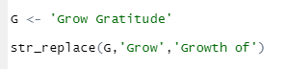 

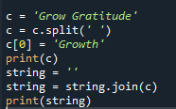 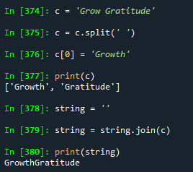

1. A story was printed in a pdf, which isn’t making any sense. i.e.:

“.elgnujehtotniffo deps mehtfohtoB .eerfnoilehttesotseporeht no dewangdnanar eh ,ylkciuQ .elbuortninoilehtdecitondnatsapdeklawesuomeht ,nooS .repmihwotdetratsdnatuotegotgnilggurts saw noilehT .eert a tsniagapumihdeityehT .mehthtiwnoilehtkootdnatserofehtotniemacsretnuhwef a ,yad enO .ogmihteldnaecnedifnocs’esuomeht ta dehgualnoilehT ”.emevasuoy fi yademosuoyotplehtaergfo eb lliw I ,uoyesimorp I“ .eerfmihtesotnoilehtdetseuqeryletarepsedesuomehtnehwesuomehttaeottuoba saw eH .yrgnaetiuqpuekow eh dna ,peels s’noilehtdebrutsidsihT .nufroftsujydobsihnwoddnapugninnurdetratsesuom a nehwelgnujehtnignipeelsecno saw noil A”

You have noticed that the story is printed in a reversed order. Rectify the same and write a code to print the same story in a correct order.

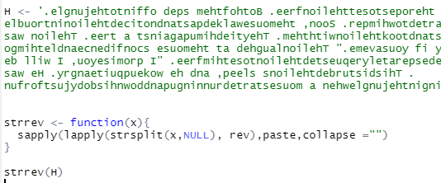

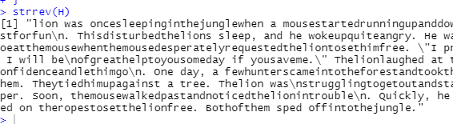

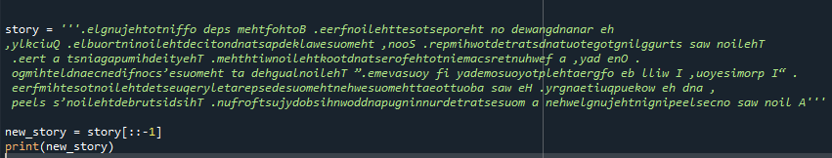

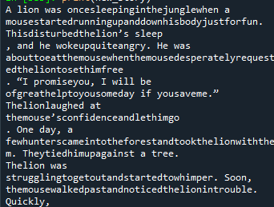

**Hints:**

For each assignment, the solution should be submitted in the below format

1. Research and perform all possible steps for obtaining solution

3. All the codes (executable programs) should execute without errors

4. Code modularization should be followed

5. Each line of code should have comments explaining the logic and why you are using that function